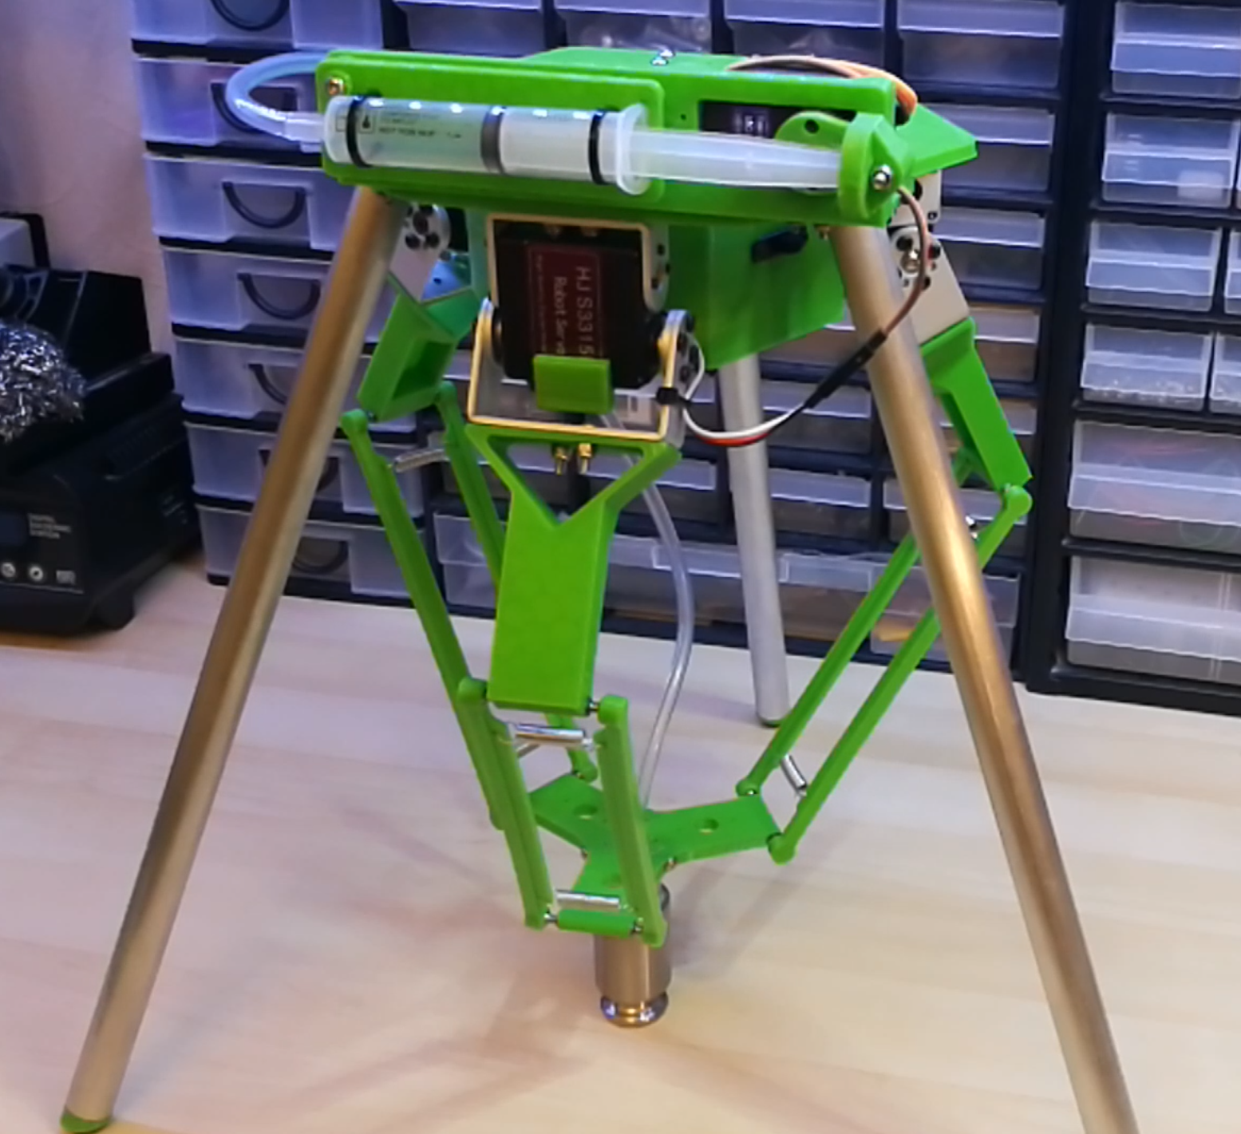

Closed-Loop Delta Robot for Automated Inspection and Sorting
A Servo-Driven, 3D-Printed Delta Robot

1. Abstract
This report presents the design and proposed control upgrade of a low-cost delta (parallel-link) robot for use in an automated inspection and sorting cell. The mechanical and electronic baseline is an open-source, 3D-printed, servo-driven delta robot design with three translational degrees of freedom plus an independently driven end-effector rotation stage, later retrofitted with legs and a working syringe-actuated vacuum gripper for pick-and-place use. It uses three HJ S3315D servos to actuate the parallel arms and an Arduino Nano to generate the joint commands from Cartesian targets. Building on this open-loop servo baseline, this report proposes a closed-loop control architecture — combining position/torque feedback, a camera-based part-detection stage, and a supervisory sorting controller — that adapts the design for repeatable pick-and-place inspection and sorting tasks on a small parts line.

2. Introduction
Delta robots use three parallel kinematic chains connecting a fixed base to a moving end-effector plate, which in the classical arrangement keeps the end effector's orientation fixed while allowing fast, high-acceleration translational motion in a bowl-shaped workspace beneath the base. This kinematic arrangement, combined with lightweight distal linkages, makes delta robots well suited to high-speed pick-and-place work such as sorting, packaging, and light assembly — tasks traditionally dominated by industrial units from vendors such as ABB, Fanuc, and Omron.
The robot described here originates from an open-source, single-builder project, distributed as a set of 3D-printable parts with companion Arduino firmware and documented across a two-part video build log. It demonstrates that a functional delta manipulator — including a purpose-built end-effector rotation stage, add-on legs, and a working syringe-actuated vacuum gripper — can be built from PLA-printed links, an aluminium-tube leg structure, hobby servos, and an Arduino Nano for well under the cost of a commercial unit. This report documents that baseline design, including the extensions already built by its creator, and then extends it conceptually further into a closed-loop, sensor-integrated cell aimed at automated visual inspection and sorting of small parts.

3. System Architecture

3.1 Mechanical Design
The mechanism follows the classical delta-robot topology: a fixed upper base carries three actuator brackets spaced 120° apart, each driving a rigid proximal arm (“link 1”). Each proximal arm connects to a lightweight two-rod parallelogram (“link 2”) through spring-preloaded M3 ball-and-socket joints, which removes backlash from the joint without requiring a rigid revolute bearing at every corner. The three parallelogram pairs converge on a common end-effector plate; in a classical delta this constrains the plate to pure translation (no rotation), but this build deliberately breaks that constraint by mounting the plate on a bearing race so a fourth, independently driven stage can rotate it about its own axis, giving the end effector a combined 3-DOF translation plus 1-DOF rotation motion. Aluminium tubes (16 mm OD, 333 mm long) form the legs that hold the base above the working volume; these legs, together with 3D-printed feet fitted with rubber inserts, were added in a second build phase to orient the workspace beneath the base for pick-and-place use, after which the inverse-kinematics firmware was updated to account for the inverted geometry. All structural parts — base, arms, effector plate, pulley/bearing caps, and leg feet/brackets — were modelled in Autodesk Inventor, exported as STL, sliced, and 3D-printed in PLA on a Prusa i3-style FDM printer with 15–25% honeycomb infill; parts were designed to print without support material to simplify clean-up.
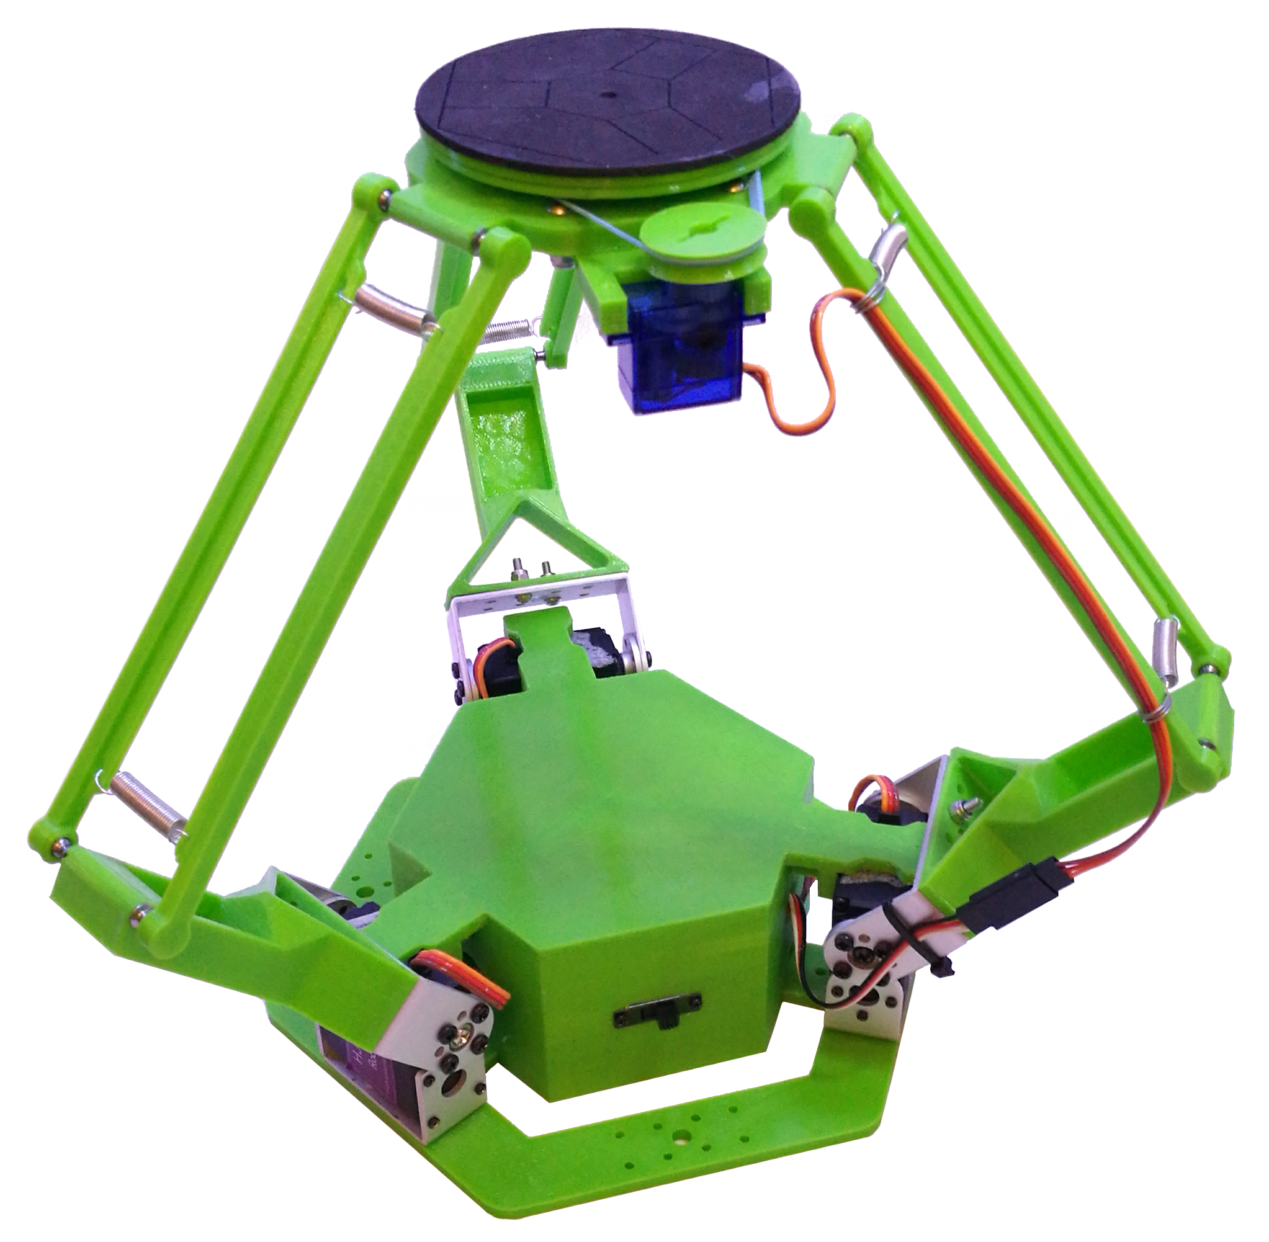
Figure 1. Cutaway render of the base assembly, showing the three servo-driven proximal arms, the parallelogram linkages, ball-stud joints, and the central end-effector actuator bay.
A fourth SG90 micro-servo, modified for continuous rotation, drives the end-effector rotation stage through an elastic drive band running on the bearing race described above; the builder notes the elastic band can stretch and cause jerky motion, and intends to replace it with a printed flexible-filament belt for smoother running. This rotation stage gives the tool plate its own rotational axis independent of the three positioning arms. A separate end-effector, described in Section 3.4, adds a fifth servo to actuate a vacuum-based gripper so parts can be lifted and released into a sorting bin.

3.2 Actuation
- 3 × HJ S3315D digital servos — drive the three proximal arms and set the end-effector position in X, Y, Z.
- 1 × SG90 micro servo, modified for continuous rotation — drives the end-effector platform's rotation about its own axis via a belt/bearing-race stage (a genuine 4th DOF, not a gripper actuator).
- All actuators are commanded as standard PWM servo signals from the Arduino Nano's digital I/O pins.
- Optional 5th actuator — an MG995 servo, fitted only when the syringe vacuum gripper (Section 3.4) is attached, drives the syringe plunger to generate suction.

3.3 Electronics and Control Hardware
Power is supplied by a 3S 11.1 V LiPo battery. A buck regulator steps this down to a regulated ~6 V, ~5 A rail for the four servos, buffered by 1000 μF and 330 μF capacitors to absorb the current transients of simultaneous servo moves. An Arduino Nano generates the PWM position commands and, via an HC-05 Bluetooth module wired through a resistor-divider level shifter, accepts wireless motion commands from a host PC or app. A physical switch and voltage-divider sensing on two analog inputs allow the firmware to monitor battery state.
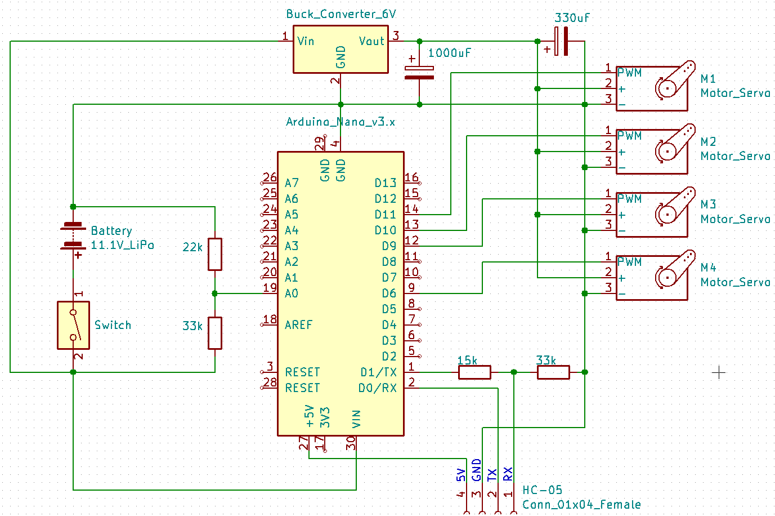
Figure 2. Power and control schematic: LiPo battery, buck regulator, Arduino Nano, HC-05 Bluetooth link, and the four servo channels.

3.4 End Effectors
Three interchangeable tools were designed, printed, and tested on the rotating end-effector platform:
- Basic grip mount — a simple friction fitting with a laser-cut foam pad bonded on for extra grip, used for early handling tests with light objects.
- Stylus/pen clamp — three adjustable jaw screws and a tapered clamping bore grip a pen, stylus, or similar object; because it mounts inside the rotating platform, the clamped tool rotates as well. This was used for accuracy testing and for driving a stylus against a phone or tablet screen.
- Syringe-actuated vacuum gripper — the most involved of the three, comprising a 3D-printed frame, a syringe used as the vacuum pump, and a cast suction cup moulded from 1:1 mix silicone. The MG995 servo drives the plunger through a printed lever arm that extends its travel, drawing roughly 7 mL of air per stroke and generating enough suction to hold a part. The servo arm is kept in line with the syringe shaft at full retraction so the vacuum's return force is reacted through the servo's output shaft rather than its gears and motor, letting the gripper hold its seal on minimal current. In testing it lifted a ~300 g padlock before the seal broke, and held a smooth metal test weight under vacuum for over 24 hours before it let go; it only works on smooth, non-porous surfaces capable of an airtight seal, and — as built — has no pressure or current sensor to confirm a pick.

4. Working
Each of the three base servos rotates its proximal arm through a limited arc; the spring-preloaded parallelogram attached to that arm transmits this rotation to the end-effector plate while constraining it to translate rather than rotate. Because the three arms act on the same plate from 120° apart, driving all three servos to a coordinated set of angles pulls the plate to a specific point in three-dimensional space — rotating one arm alone sweeps the plate along an arc, while coordinated motion of all three produces straight-line or curved translational moves anywhere inside the workspace.
In operation, the Arduino Nano receives a target position (or a motion command) over the Bluetooth link, resolves it to the three proximal arm angles using the inverse kinematics described below, and writes the corresponding pulse widths to the three arm servos. The rotation-stage servo and the fitted end effector are driven independently to spin the platform and to open, close, or actuate the tool once the plate has reached its target. The firmware repeats this cycle at each new command, so a full pick-and-place move is simply a short sequence of target positions — above the part, at the part, lifted, and over the destination — sent one after another, with the tool actuated between the relevant steps. Battery voltage is monitored throughout via the analog divider inputs so the firmware can flag a low-charge condition before it affects servo torque.
Motion sequences are currently built by a teach-and-playback workflow rather than by automated planning: the operator jogs the end effector to a pose over Bluetooth, records that position, repeats this for each point in the desired path, and then executes the recorded sequence, with the firmware interpolating between consecutive points for smooth motion and repeating the whole sequence a specified number of times. This is the mechanism used today for repetitive tasks such as agitating a chemical bath; it has no perception or force feedback of its own and is distinct from the closed-loop, vision-guided sequencing proposed in Section 6.

5. Kinematics
For a delta robot, the inverse kinematics problem — given a desired end-effector position (x, y, z), find the three proximal arm angles θ1, θ2, θ3 — has a closed-form solution because each arm/parallelogram pair constrains the effector to lie on a sphere of radius equal to the parallelogram (“link 2”) length, centred on the corresponding elbow point. Intersecting that sphere with the circle traced by the proximal arm's elbow yields the joint angle for each of the three symmetric limbs. The firmware evaluates this closed-form solution at each motion update, converts the three angles to servo pulse widths, and writes them out on the PWM channels. The forward kinematics — recovering (x, y, z) from three known joint angles — is used mainly for verification and for reporting the current tool position back over Bluetooth, since it requires solving a small system of sphere-intersection equations rather than a single closed form.
The reachable workspace is a roughly cylindrical, dome-topped volume set by the proximal arm length, the parallelogram length, and the base/effector plate radii; link lengths and servo range in this design were chosen to keep the whole workspace within the servos' safe angular travel while leaving mechanical clearance between the three arms at full extension.

6. Closed-Loop Control Architecture for Inspection and Sorting
The baseline firmware is open-loop with respect to the end-effector: it commands servo angles computed from the kinematics and trusts the RC servos' internal position loops to reach them, with no external verification of where the tool actually ended up or what part, if any, is present at the pick point. For an inspection-and-sorting task — where a wrong pick, a dropped part, or a misclassified item has a direct cost — this needs to be closed at three levels. The syringe-actuated vacuum gripper described in Section 3.4 already provides a physical end effector suited to a sorting cell, but as built it is purely mechanical and carries none of the sensing described below.
- Joint-level feedback: replacing or augmenting the hobby servos with feedback-capable actuators (e.g. servos with analog position taps, or magnetic encoders on the proximal arm shafts) so the controller can confirm each arm reached its commanded angle and detect stall or collision before completing a place cycle.
- Perception feedback: a fixed overhead or in-line camera identifies part presence, pose, and (for inspection) pass/fail attributes such as dimension, colour, or surface defects, feeding target coordinates and a sort classification to the motion controller instead of a fixed pick point.
- Task-level feedback: a supervisory state machine confirms each pick (via gripper current or a vacuum-pressure switch) and each place (via a bin-level or photo-interrupt sensor) before advancing the sequence, retrying or flagging a fault if confirmation fails.
Architecturally, this moves the Arduino Nano from a pure servo-angle sequencer to the inner loop of a two-tier controller: a vision/host PC computes what to pick and where to place it, streams Cartesian targets and a gripper/sort command to the Nano over the existing Bluetooth link, and the Nano closes the fast inner loop (inverse kinematics, servo commands, joint and grip confirmation) and reports completion or fault status back up.

7. Application Workflow: Inspection and Sorting
A representative cycle for the closed-loop cell proceeds as follows:
- 1. Acquire — a part arrives on the infeed (e.g. a conveyor or vibratory tray) and the vision stage captures an image and locates it.
- 2. Classify — the vision stage measures the part and assigns it to a sort class (e.g. pass/fail, or a size/colour bin) and computes the pick coordinates.
- 3. Plan — the host resolves the pick and place coordinates to joint targets using the delta inverse kinematics and sends them to the Arduino Nano.
- 4. Pick — the robot moves to the pick pose, actuates the end-effector tool, and confirms grip via current/pressure feedback.
- 5. Sort — the robot transits to the bin or lane assigned to the part's class and releases it, confirming release before returning to a ready pose.
- 6. Verify and log — a successful/failed cycle is logged; failed picks trigger a re-attempt or reject-lane routing.

8. Bill of Materials
The core electromechanical bill of materials, carried over directly from the open-source baseline design, is summarised below, together with the parts added for the leg/pick-and-place retrofit and the interchangeable end effectors described in Sections 3.1 and 3.4. Fasteners and wiring consumables are grouped for brevity; full quantities are listed in the original project documentation.
Item | Qty | Notes
HJ S3315D robot servo (arm actuation) | 3 | With mounting brackets and bolts
SG90 9 g micro servo (end-effector actuation) | 1 | With servo arms and screws
Arduino Nano | 1 | Main motion controller
Buck voltage regulator | 1 | 12.6 V in, ~5 A @ 6 V out for servo rail
HC-05 Bluetooth module | 1 | Wireless command / telemetry link
M3 ball studs (4.8 mm ball, 10 mm thread) | 12 | Parallelogram linkage joints
M3 button-head bolts, 8 mm | 24 | General assembly
M3 button-head bolts, 12 mm | 2 | General assembly
M3 Nyloc nuts | 26 | General assembly
Tension springs, ~20 mm | 6 | Preload the ball-joint linkages
4 mm ball bearings | — | Base and effector rotation points
3S 11.1 V 1000 mAh LiPo battery | 1 | Onboard power
Aluminium tubing, 16 mm OD / 14 mm ID | 3 × 333 mm | Structural legs
PLA filament | — | 3D-printed base, arms, effector
3D-printed leg brackets and feet | 3 each | Feet fitted with rubber inserts to prevent slipping
MG995 servo (vacuum gripper) | 1 | Actuates the syringe plunger via a printed lever arm
Plastic syringe (vacuum pump) | 1 | Draws ~7 mL of air per stroke
1:1 mix silicone (mould-making rubber) | — | Cast into a suction cup using 3D-printed moulds
Stylus/pen clamp end effector | 1 | 3D-printed, 3 adjustable jaw screws + tapered clamp bore

9. Results and Performance Calculations
The figures below are derived directly from the component specifications given in the project's own bill of materials — the 3S 1000 mAh 20C battery, the buck regulator's rated input/output, and the aluminium leg-tube dimensions — together with the standard density of aluminium. No performance figures for the individual servos are assumed, since the source documentation does not specify their speed or torque; where a converter efficiency had to be assumed for a calculation, that assumption is stated alongside the result.
Metric | Basis / Calculation | Result
Battery energy capacity | 11.1 V × 1.0 Ah (3S 1000 mAh pack) | 11.1 Wh
Maximum discharge current | 1.0 Ah × 20C rating | 20 A
Servo-rail power budget | 6 V × ~5 A rated regulator output | ≈ 30 W
Estimated battery-side input current | 30 W ÷ 11.1 V ÷ assumed 85% converter efficiency | ≈ 3.2 A
Leg tube mass (each) | π/4 × (16² − 14²) mm² × 333 mm × 2.70 g/cm³ | ≈ 42 g
Total leg mass (3 legs) | ≈ 42 g × 3 | ≈ 127 g

The battery's rated 20C discharge figure means the 1000 mAh pack can in principle supply up to 20 A in bursts, and its 11.1 V nominal rating gives a usable energy budget of 11.1 Wh per charge — both figures read directly off the cell's own rating rather than a measurement. The buck regulator's specified output of approximately 5 A at 6 V sets a servo-rail power budget of about 30 W; assuming a typical switching-regulator efficiency of around 85%, the corresponding draw on the battery side works out to roughly 3.2 A at the pack's 11.1 V nominal voltage, comfortably inside the cell's 20 A discharge limit.
The leg tubing's stated dimensions — 333 mm long, 16 mm outer diameter, 14 mm inner diameter — fix its cross-sectional area at π/4 × (16² − 14²) mm² ≈ 47.1 mm² and its volume at approximately 15.7 cm³. At a standard aluminium density of 2.70 g/cm³ this gives a mass of roughly 42 g per leg, or about 127 g for the three-legged stand — a fixed, calculable contribution to the overall structure's mass, independent of the 3D-printed parts.
Unlike the figures above, which are calculated from component ratings, the syringe vacuum gripper's performance was measured directly. Lifting a padlock from a digital scale, the gripper held up to roughly 300 g before the suction seal broke, with the result repeatable across several trials — noted as a static load limit only, since any significant motion with a load that heavy is likely to shake the part loose. Holding a smooth metal test weight under vacuum, with no motion, it maintained the seal for over 24 hours before the part fell free, consistent with the design intent that a good seal should hold indefinitely and that failures are dominated by small leaks rather than by the mechanism relaxing over time.

10. Future Work
- Instrument the three proximal arms with low-cost magnetic or potentiometric encoders to close the joint position loop independently of the servos' internal feedback.
- Add a pressure or current sensor to the existing syringe-actuated vacuum gripper (Section 3.4) so a pick can be confirmed automatically instead of being assumed.
- Integrate a fixed overhead camera and a lightweight classifier to drive part localisation and pass/fail or category sorting.
- Characterise positioning repeatability against payload and cycle rate to quantify the gap between the open-loop baseline and the closed-loop upgrade.
- Replace the aluminium-tube/PLA leg structure with a stiffer frame if repeatability at higher speeds proves compliance-limited.

11. Conclusion
This open-source delta robot provides a mechanically sound, low-cost parallel-kinematic design — three servo-driven arms, spring-preloaded ball joints, a rotating end-effector platform, and an Arduino Nano controller — that has already been extended, in its as-built form, well beyond a bare demonstration rig: aluminium legs and printed feet reorient it for pick-and-place, and a working syringe-actuated vacuum gripper has been built and measured, lifting loads of roughly 300 g and holding vacuum for over 24 hours. Its control loop remains open-loop at the end-effector — motion is produced by teaching and replaying recorded points rather than by any perception or force feedback — which is sufficient for repeatable, pre-programmed pick-and-place but not for verified, adaptive sorting. The closed-loop architecture proposed in this report — joint feedback, camera-based classification, and task-level pick/place confirmation layered over the existing kinematics, servo firmware, and vacuum end effector — targets that gap directly, and can be implemented incrementally on the existing hardware without a mechanical redesign.

12. Sources
- isaac879, "3D Printed Delta Robot (Servo Driven)" and "3D Printed Delta Robot (Arduino Controlled)" — project build-log videos.
- isaac879, "Vacuum Gripper (Syringe Suction Gripper) For My 3D Printed Delta Robot" — project build-log video.
- isaac879, "3D Printed Delta Robot (Servo Driven)," Thingiverse, thing:3465651 — STL files and bill of materials.
- isaac879, Delta-Robot Arduino Nano firmware, GitHub: github.com/isaac879/Delta-Robot.

